

DLMDSME01

Automation of Standby Duty Planning for Rescue Drivers via a Forecasting Model

Niels Humbeck

32003045

19.11.2021

Köln, Germany

# Table of contents

1 Table of contents 2

2 Image directory 3

3 Abbreviations 3

4 Facial Recognition Technology 4

5 Comparison of potential benefits and threats on society using facial recognition 4

6 Regulation frameworks in USA, EU and China 4

7 Reconciliation of the benefits and threats 4

8 Outlook: 4

8.1 Key requirements 18

1. Literature 20

(Hint: remember to actualize the table of contents)

# Image directory

# Abbreviations

# Introduction:

Model Engineering … very important --- case study to get experience

XX% of the data science project make it to the development. The low success rate has different reasons. One reason is the low description of the use case another reason is the structure of data science projects. In the given work we describe based on the Teams Data Science Process methodology a use case of model engineering for a automation of standby duty planning for rescue drivers.

In the first chapter the used methodology for the given case study in model engineering is explained. The applied framework is called “Teams Data Science Process (TDSP)”. TDSP is a framework providing a structural methodology to conduct data science projects. Based on the framework the first chapter provides basic understanding of the business. The focus is set here especially on the problem description, the goal of the data science project, the measures how to quantify the success of the project and the benefits.

The third chapter is about data acquisition & understanding…

The furth chapter….

Teams Data Science Process (TDSP)

The core concept of the TDSP is depicted in the figure below (see Figure 1).

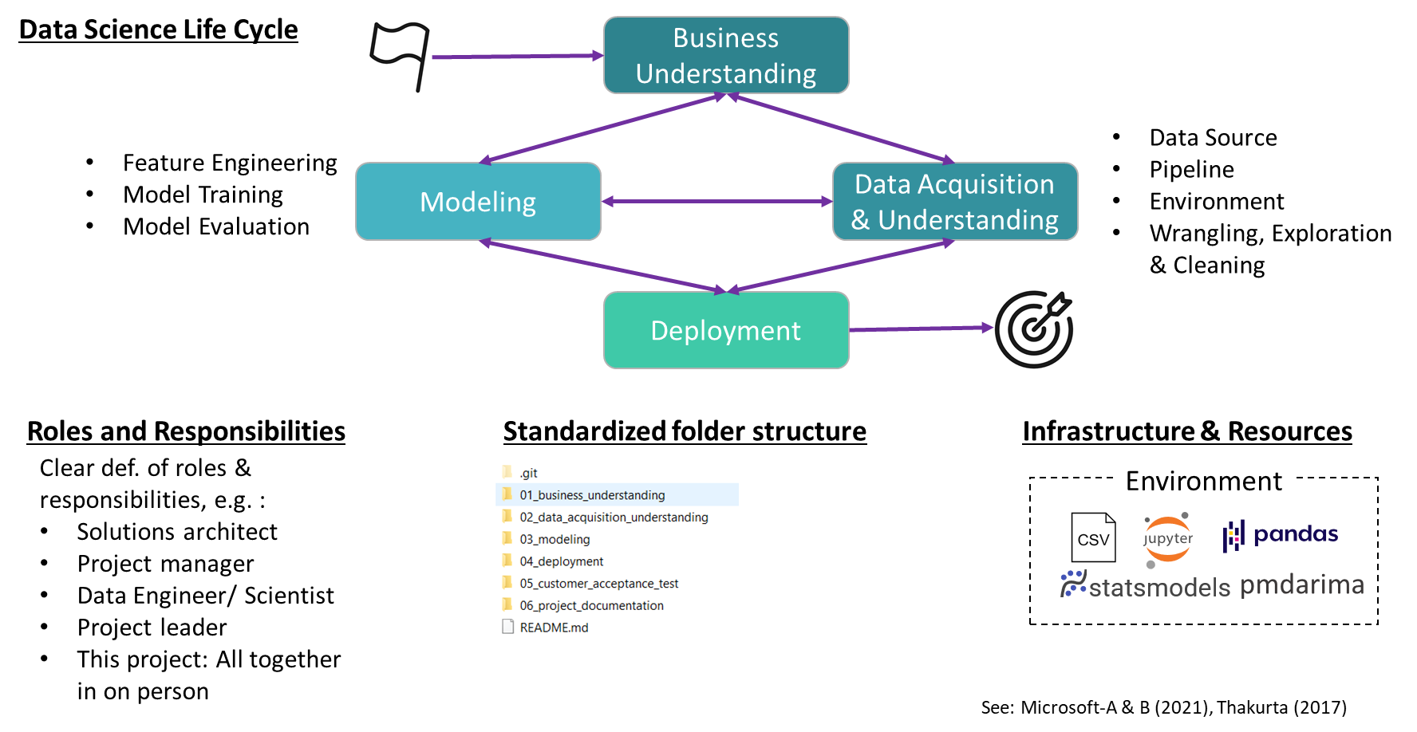

Figure 1: The Teams Data Science Process (TSDP)

The TDSP contains a data science life cycle, the standardized roles and responsibilities, the standardized folder structure and the infrastructure & resources (Microsoft-A, 2021). The data science life cycle described in s flexible and iterative manner a methodic ho to conduct data science project. The very first step is to understand the business and its needs. Together with the subject matter experts – who has the needed domain knowledge – the data scientist describes the problem and outlines the goal of the data science projects. It is important to define in the beginning quantifiable success measures. In the next step the data is acquired and analyzed: Which data sources are available, creating data pipelines, accessing the quality of the data, cleaning the data, exploring hidden patterns in the data. Based on the given data a model is trained in order to serve the business needs. Feature engineering is conducted before model training to provide meaningful input values. After the model is trained a evaluation is conducted. If the evaluation meet the measurable success criterias, the model is deployed in production. All of this steps are iterative an interconnected. For example a first trained model is shown to the subject matter expert to get a feedback (Microsoft-B, 2021).

The TDSP outlines the key personal roles and associated tasks. Basic roles in a data science project are: solutions architect, project manager, data engineer, data scientist, project lead (Thakurta, 2017). Besides roles and responsibilities the framework advocates clear folder structure as well as the use of a version control software to enable the team work. In the given project git hub is used as the version control system. The used folder structure is depicted in Figure 1. Further more TDSP gives advises for the infrastructure to use in a data science project.

# Business understanding

Berlins red-cross is a charity-oriented organization providing ambulance transport services. The organization incorporates 51000 members, 2500 volunteer workers and 1000 full time employees. Operating ambulance transports is a ethical sensible environment since lives depends on the reliability and availability of these transports. That’s why sufficient capacities of ambulance transport is eminent to the business success.

The business faced in the past difficulties with insufficient planning of the standby-duty planning of rescue drivers. The number of rescue drivers needed highly depends on the amount of emergency calls received per day. For each day a predefined number of rescue driver as well as standby rescue drivers is on duty. Short-term sickness of rescue drivers as well as unusual high amounts of emergency calls results in an unusual high demand of rescue drivers which can exceed the amount of available rescue drivers. Unusual low short-term sickness of rescue drivers as well as unusual low amounts of emergency calls – on the other side - results in an unusual low demand of rescue drivers. In this case the amount of planned standby drivers are not needed. The goal of the given data science project is to create a model which predicts on the 15th for the upcoming month the demand of rescue drivers (inc. Standby divers) for the next month. The prediction is influenced by seasonal patterns. The success of developed model is measured by:

* percentage of standbys being activated is higher than in the current approach of keeping 90 drivers on hold
* situations with not enough standbys should occur less often than in the current approach.

A successfully deployed prediction model in the production has several benefits:

* Improved prediction of demand of rescue drivers results in less cost for providing idle capacities
* Higher reliability in duty planning returns in higher free time quality of employees
* Increase in trust in the capabilities of Berliner Red-Cross to cope with the

# Data Acquisition & Understanding

# Library

* Microsoft-A (2021), Was ist der Team Data Science-Prozess (TDSP)?, <https://docs.microsoft.com/de-de/azure/architecture/data-science-process/overview>, last access: 18.11.2021 at 21:20
* Microsoft-B (2021), Lebenszyklus des Team Data Science-Prozesses, <https://docs.microsoft.com/de-de/azure/architecture/data-science-process/lifecycle>, last access: 18.11.2021 at 21:20
* Thakurta, D., McGehee, H. (2017), Team Data Science Process: Roles and tasks, <https://github.com/Azure/Microsoft-TDSP/blob/master/Docs/roles-tasks.md>, last access: 18.11.2021 at 21:21
* Deutesches Rotes Kreuz – Berlin (2021), <https://www.drk-berlin.de/>, last access 19.11.2021 at 17:58